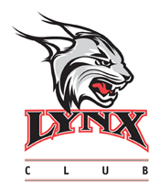
2022-2021 RHODES COLLEGE LYNX CLUB
I would like to designate my gift of $_______ to the _______________________ program.
Checks should be payable to Rhodes College. All gifts are tax-deductible.
For more information or to make a credit card gift:
https://www.rhodes.edu/content/lynx-club-athletics
Name:
Address:
City: ST: Zip:
Please return form and checks to:
Rhodes College Development
Director of Athletic Giving
Rhodes College – King Hall
2000 N. Parkway
Memphis, TN 38112

